**Genetic Algorithm Assignment**

**Finding the Optimal Water Size**

**Student**: Patrick Walsh

**School**: University of Maryland Global Campus

**Course**: CMSC 427 6980

**Date**: 7/30/2021

**Professor**: Dr. David Castillo

**Introduction**

In this scenario, I am working for an environmental management company tasked with figuring out the optimal water size system for Diamondback Terrapin turtles to thrive. Researchers have determined that water systems with less than 1,000 kiloliters of water are too small for turtles to live, but water systems with more than 10,000 kiloliters of water are too large and produce large fish that eat the turtles’ eggs. So, I know that the optimal water size will be between 1,000 and 10,000 kiloliters of water. Using a genetic algorithm, I must determine the optimal water size.

**Genetic Algorithm**

My genetic algorithm borrows from the University of Maryland Global Campus algorithm created originally to determine the optimal sale value of a product (Java Genetic Algorithm code, 2021). This algorithm takes water size as an input and generates the health of the turtles as an output. I modified the fitness function of this algorithm to generate a health value equal to the water size + 150 all divided by 140. This function is applied only to water sizes between 1,000 and 10,000 kiloliters of water.

**Conclusion**

After running the algorithm several times, I determined that the optimal water size was around 9,979 kiloliters. This produced a fitness level of 72.35, which is far from perfect, but was the strongest that this algorithm produced.

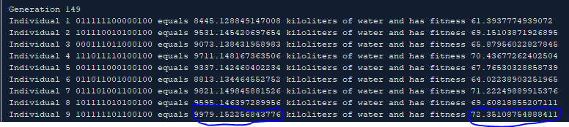

**References**

*Java Genetic Algorithm code*. (2021). [Java code provided by UMGC that creates a genetic algorithm to solve an optimal profit value]. UMGC.